Practical No: 2

**Input:**

clc;

clf;

clear all;

xn = input("enter x[n]: ");

subplot(3,1,1);

plot2d3(xn);

hn = input("enter h[n]: ");

subplot(3,1,2);

plot2d3(hn);

x_new=[];

for i = 1:length(xn)

x_new=[xn;x_new];

xn=[xn($) xn(1:$-1)];

end

yn = x_new' * hn'

subplot(3,1,3);

plot2d3(yn);

disp(yn);

**Output:**

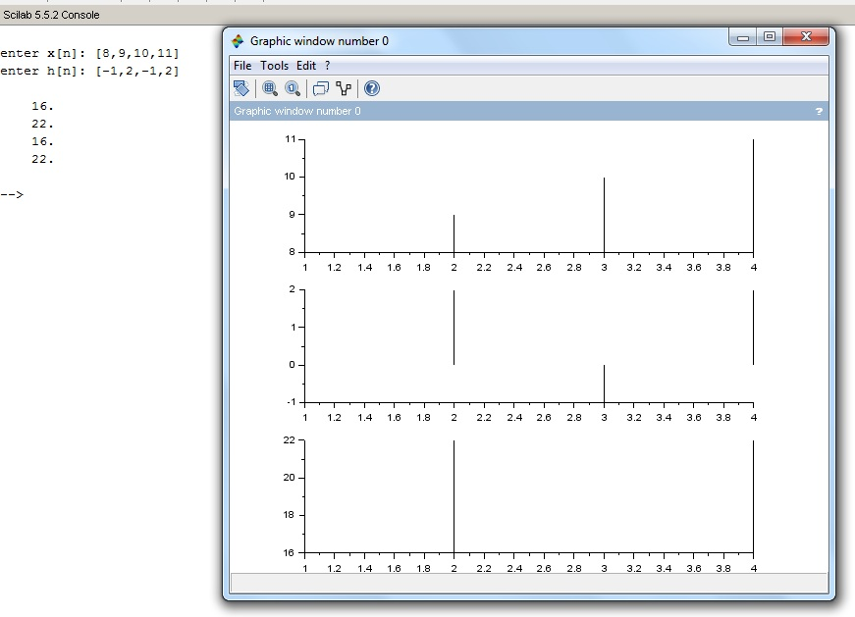

**Input:**

clc;

clf;

clear all;

L=input("Enter lengh of signal: ");

n=-L:L

xn=[zeros(1,L),ones(1,1),zeros(1,L)];

subplot(5,1,1)

plot2d3(n,xn);

title("Unit Impulse")

xlabel("n")

ylabel("del_n")

xn=[zeros(1,L),ones(1,L+1)];

subplot(5,1,2)

plot2d3(n,xn);

title("Unit Step");

xlabel("n");

ylabel("del_n");

xn=[zeros(1,L),0:L];

subplot(5,1,3)

plot2d3(n,xn);

title("Ramp");

xlabel("n");

ylabel("del_n");

b=input("Enter coeff: ");

n=-2:0.1:2;

xn=exp(b*n);

subplot(5,1,4)

plot2d3(xn);

title("Exponential");

xlabel("n");

ylabel("del_n")

**Output:**

